CLIENT | : | NEOTRAFO SOLUTIONS INDIA PRIVATE LIMITED
SITE | : | HYDERABAD
LOCATION | : | HYDERABAD, INDIA
NO. | : | -
DOCUMENT NO. | : | DBR-R00

R00 | 23-07-2026 | Design report | R.S.R | H.A.B | H.A.B
Rev No. | Date | Description | Prepared By | Checked By | Approved By

TABLE OF CONTENTS

Sr. No | Contents | Page No.
1 | Design Philosophy | 3
2 | Design Codes and Standards | 4
3 | Material Specifications Construction | 4
4 | Load Calculations | 4
4.1 | Dead Load | 5
4.2 | Live Load | 5
4.3 | EQUPMENT LOAD | 6
5 | Deflection Check | 8
6 | Primary Loads and Load Combinations | 9

- Design Philosophy
This report presents the structural design of the supporting steel framework for a moving roof system for Neotrafo at Hyderabad, India. The purpose of the supporting structure is to safely carry the load transferred from the moving roof. The overall size of the frame is 47.7x 27.85 x 5.0m high. The main sliding frame is of mild steel material. The wind load is not considered because the structure is inside the existing shade. The various DL and LL & Roof load acting at different points on frame are transferred to the nearest columns through the grid of beams.
The complete frame is modelled as 3D frame and analysed/designed for worst combination of loads through STAAD.pro. Input and output files are enclosed which are self-explanatory. From the STAAD output.
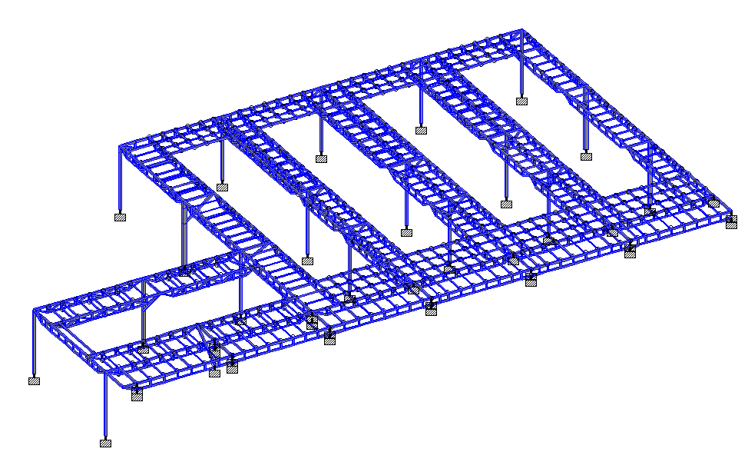

- DESIGN CODES AND STANDARDS
Code / Standard | Applicability | Remark
IS800-2007 | Design of steel structures | --
IS 875-Part I | For dead load calculation | --

- MATERIAL SPECIFICATION FOR CONSTRUCTION
Sr.no | Material | Specification | Minimum Strength
1 | Mild steel | IS2062 | Fy = 250 N/mm²

- LOAD CALCULATIONS
  - DEAD LOAD
SELFWEIGHT FACTOR = 1.1

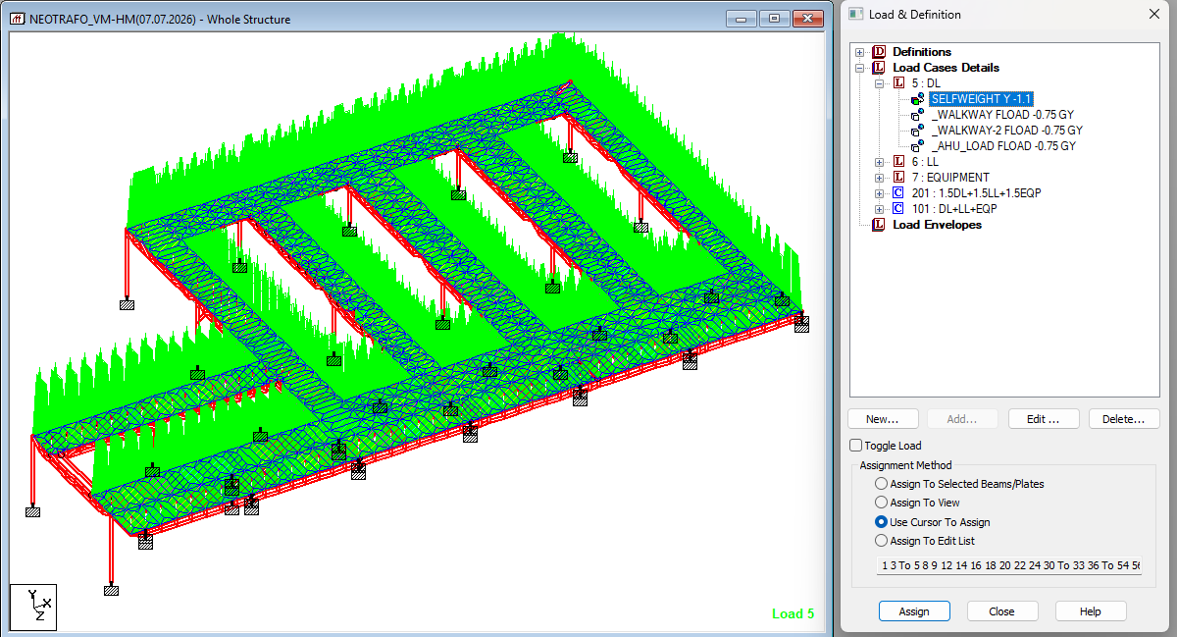

Dead load for 10mm thk. plate assumed = 75 Kg/m² i.e. 0.75 kN/m²
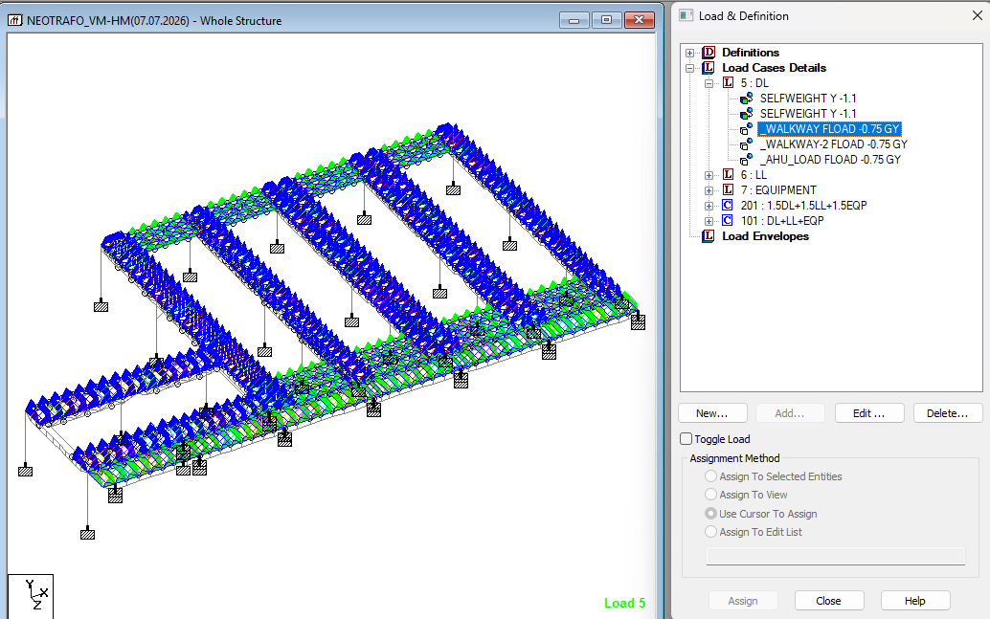
  - LIVE LOAD
Live load assumed = 1.25 kN/m²
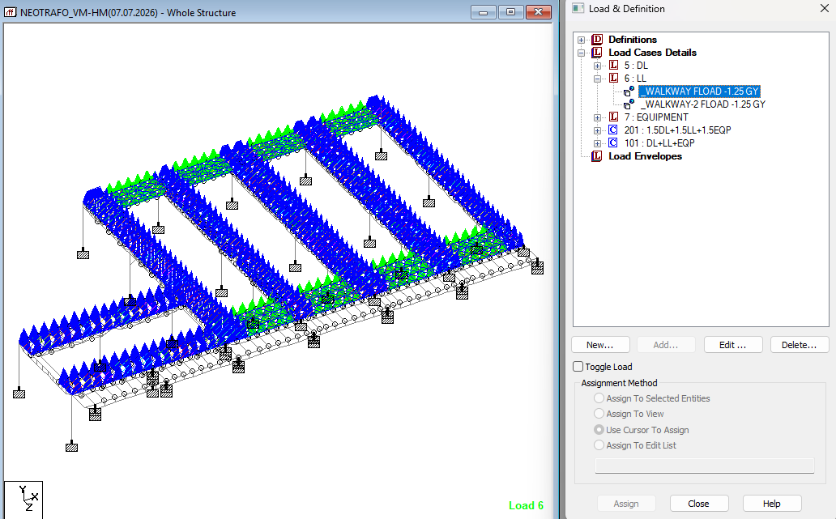

4.3 EQUIPMENT LOAD
LOADING FOR VWM & HWM
ROOF LOAD = 51.84KN (Total load of 16 ROOF)
= 51.84/4 = 12.96/2 = 6.48 KN
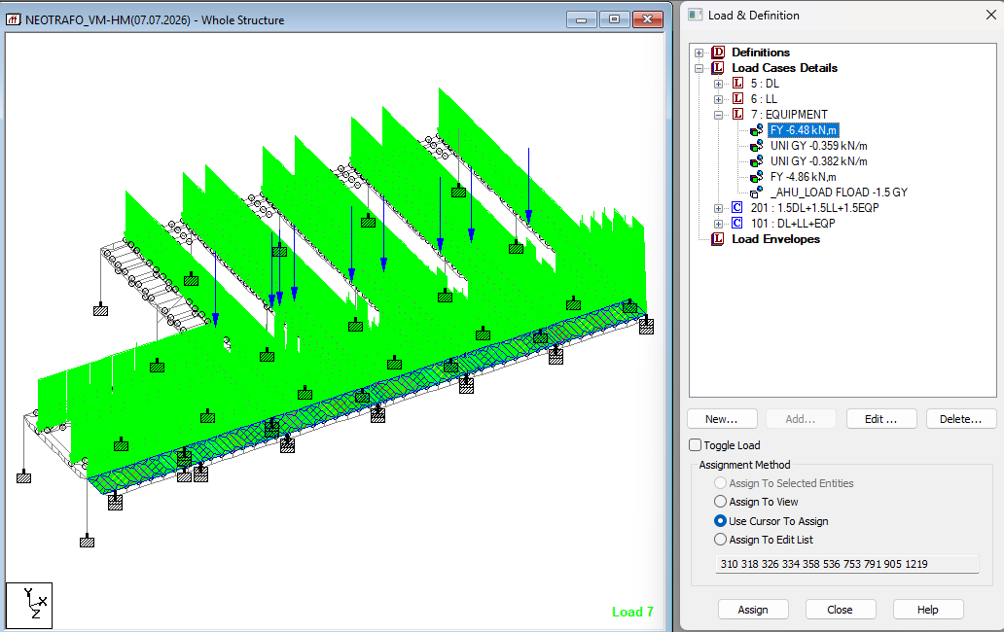
TRACK LOAD = 74.28 (Total load of 16 track)
= 74.28/4 = 18.57/2 = 9.285kN
(4 NO. OF Roof in each cutout)
= 9.285/25.801 = 0.359 KN/M2
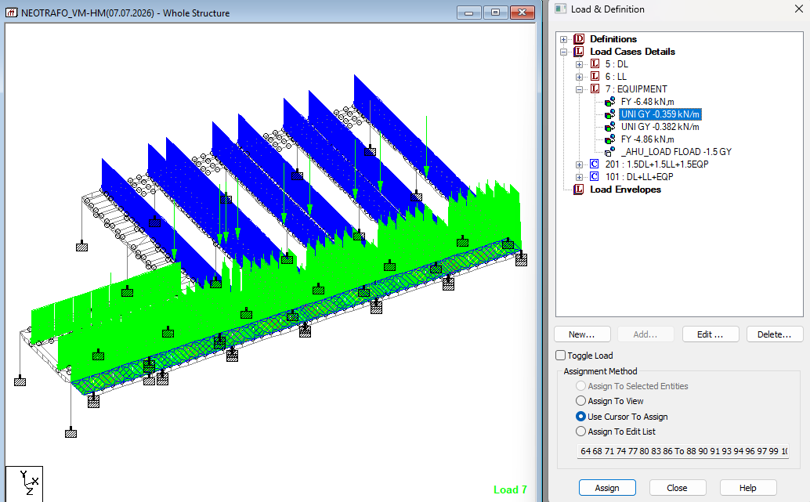
LOADING FOR SPA SHOP
ROOF LOAD = 9.72KN (Total load of 3 ROOF)
= 9.72/2 = 4.86 KN
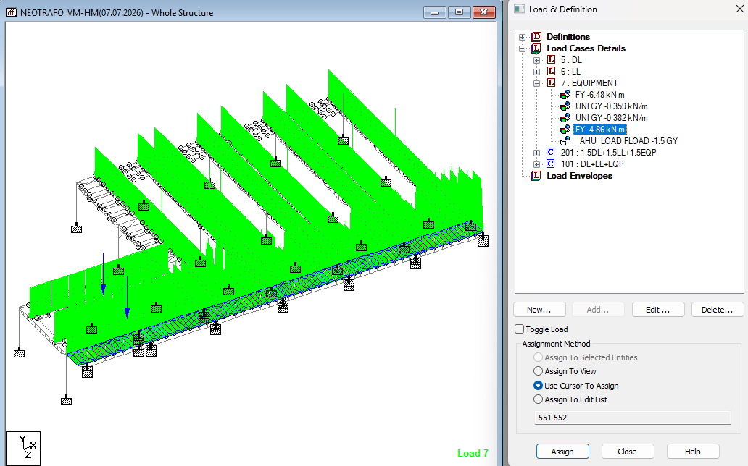
TRACK LOAD = 12.38 (Total load of 3 track)
= 12.38/2 = 6.19kN
(3 NO. OF Roof in cutout)
= 6.19/16.213 = 0.3817 KN/M2
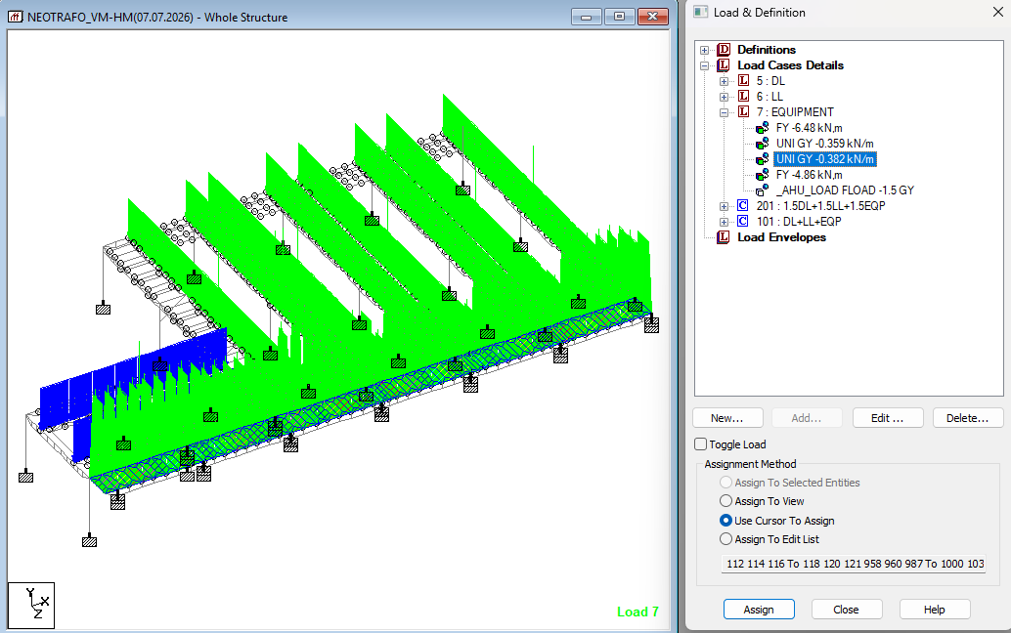
AHU load assumed = 1.5 kN/m²
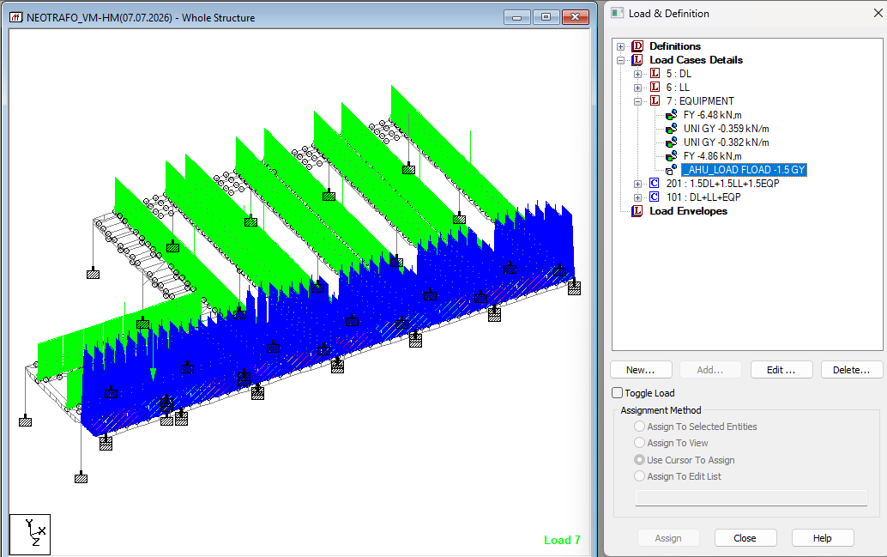
- Deflection checks at building top in Y direction
Refer node no. –982 of Staad file for load combination 101
Max. Deflection in Y dir. = 26.451 mm. < L/250 = (IS 800-2007 table 6)
.... Hence ok.
- PRIMARY LOADS & LOAD COMBINATIONS
  - PRIMARY LOADS
Load 1 Dead Load (DL)
Load 2 Live Load (LL)
Load 3 Equipment load (EQP)
  - LOAD COMBINATIONS
Load Combination for strength: -
1.5 DL + 1.5 LL +1.5 EQP
Load Combination for serviceability: -
DL + LL + EQP

